1_ first I know the approach of this gang so I started have some pics to test it to see if there's hidden data :

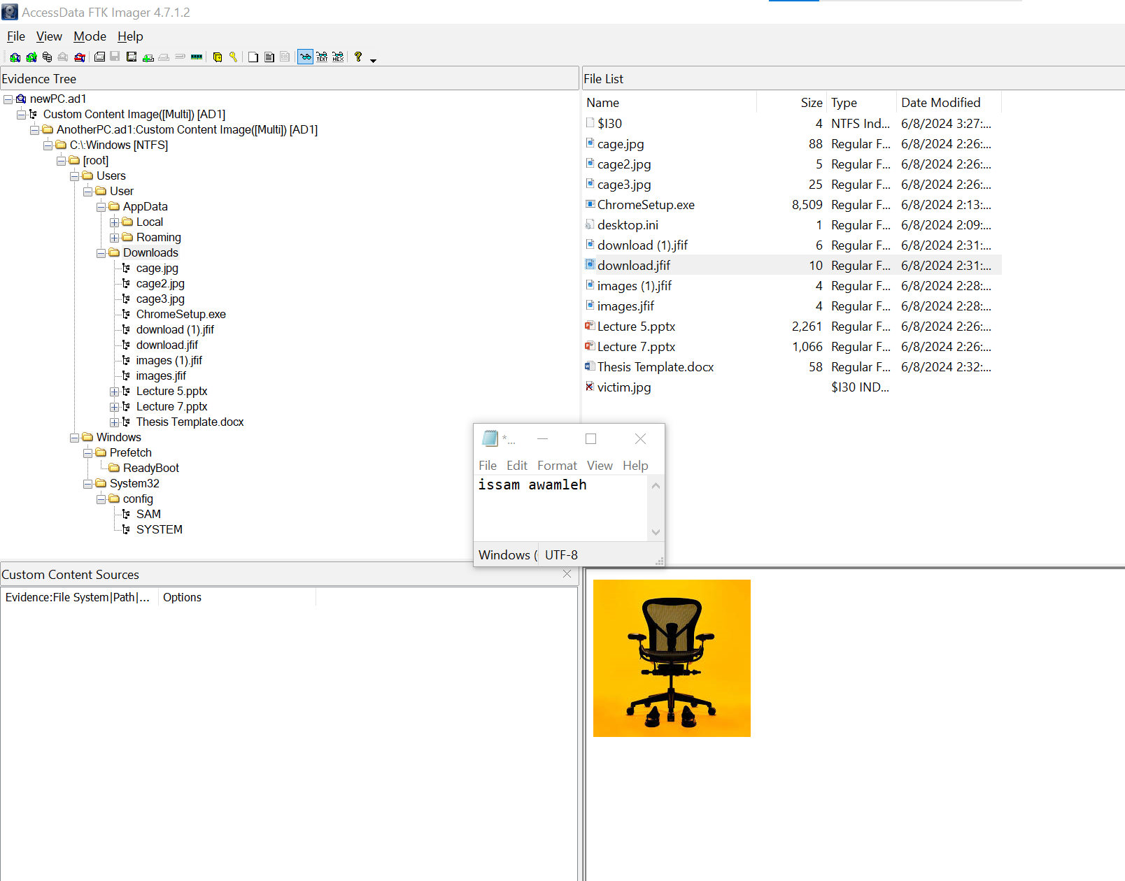

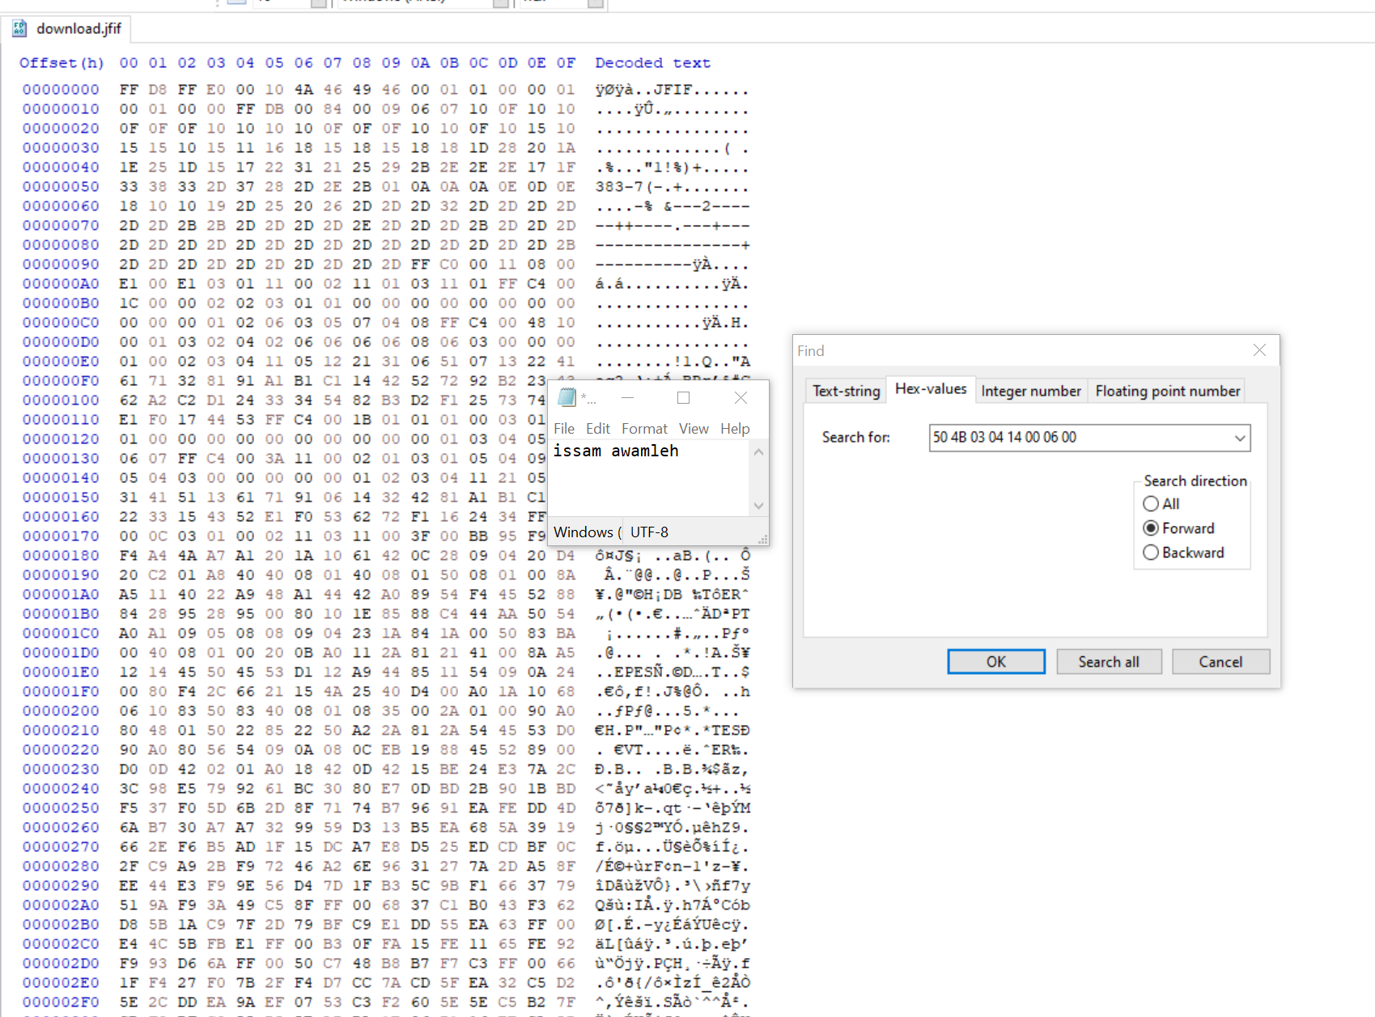

I tried with the word this templet

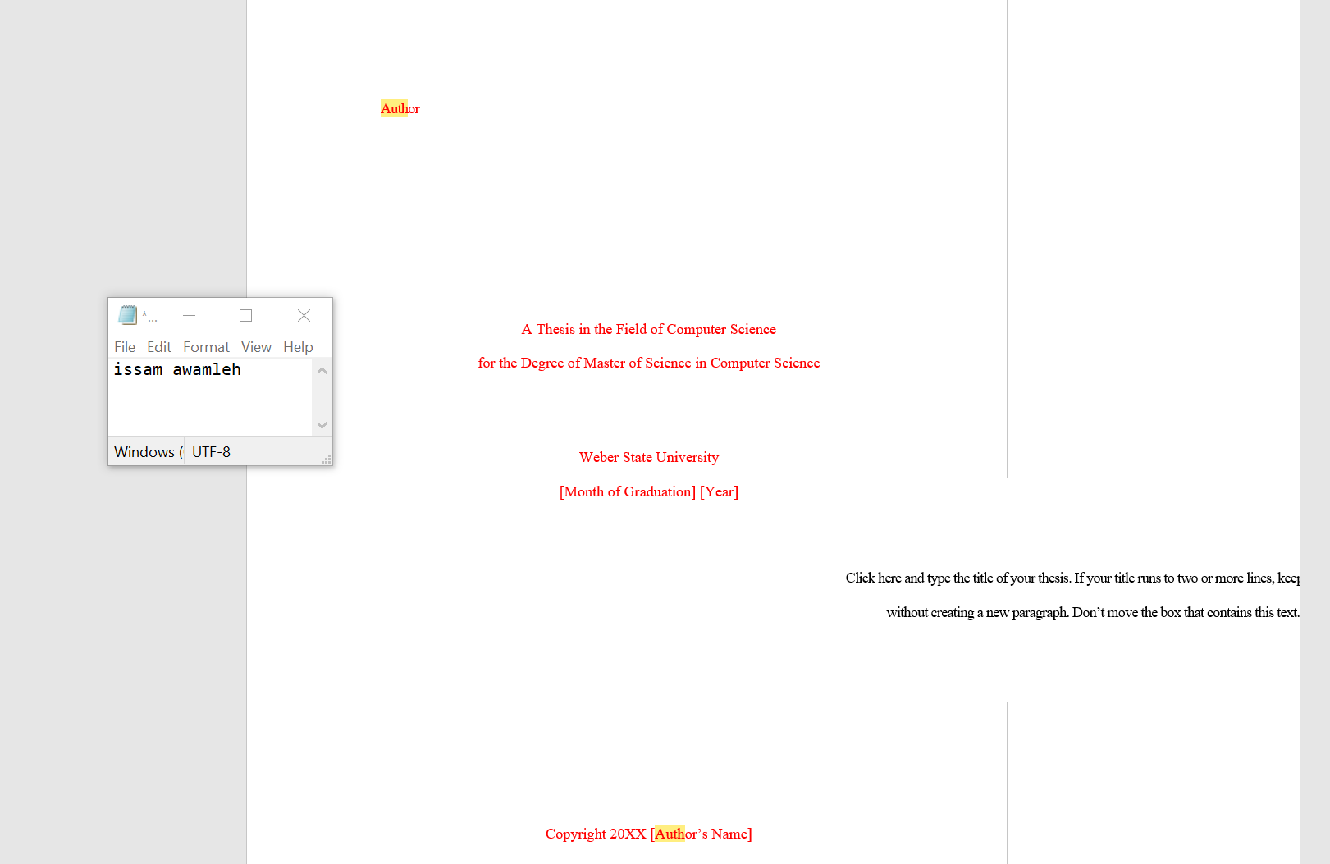

I notice something

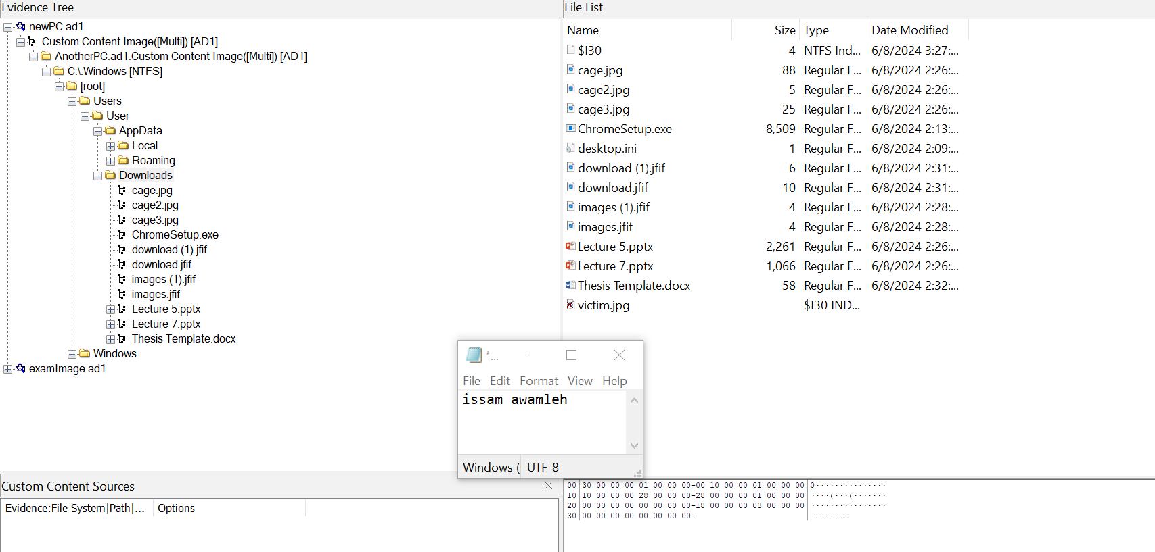

Victim.jpg so we going to use thumbnail to see it after extract the thumbnail and the victim.jpg is the only image that has that extinction.

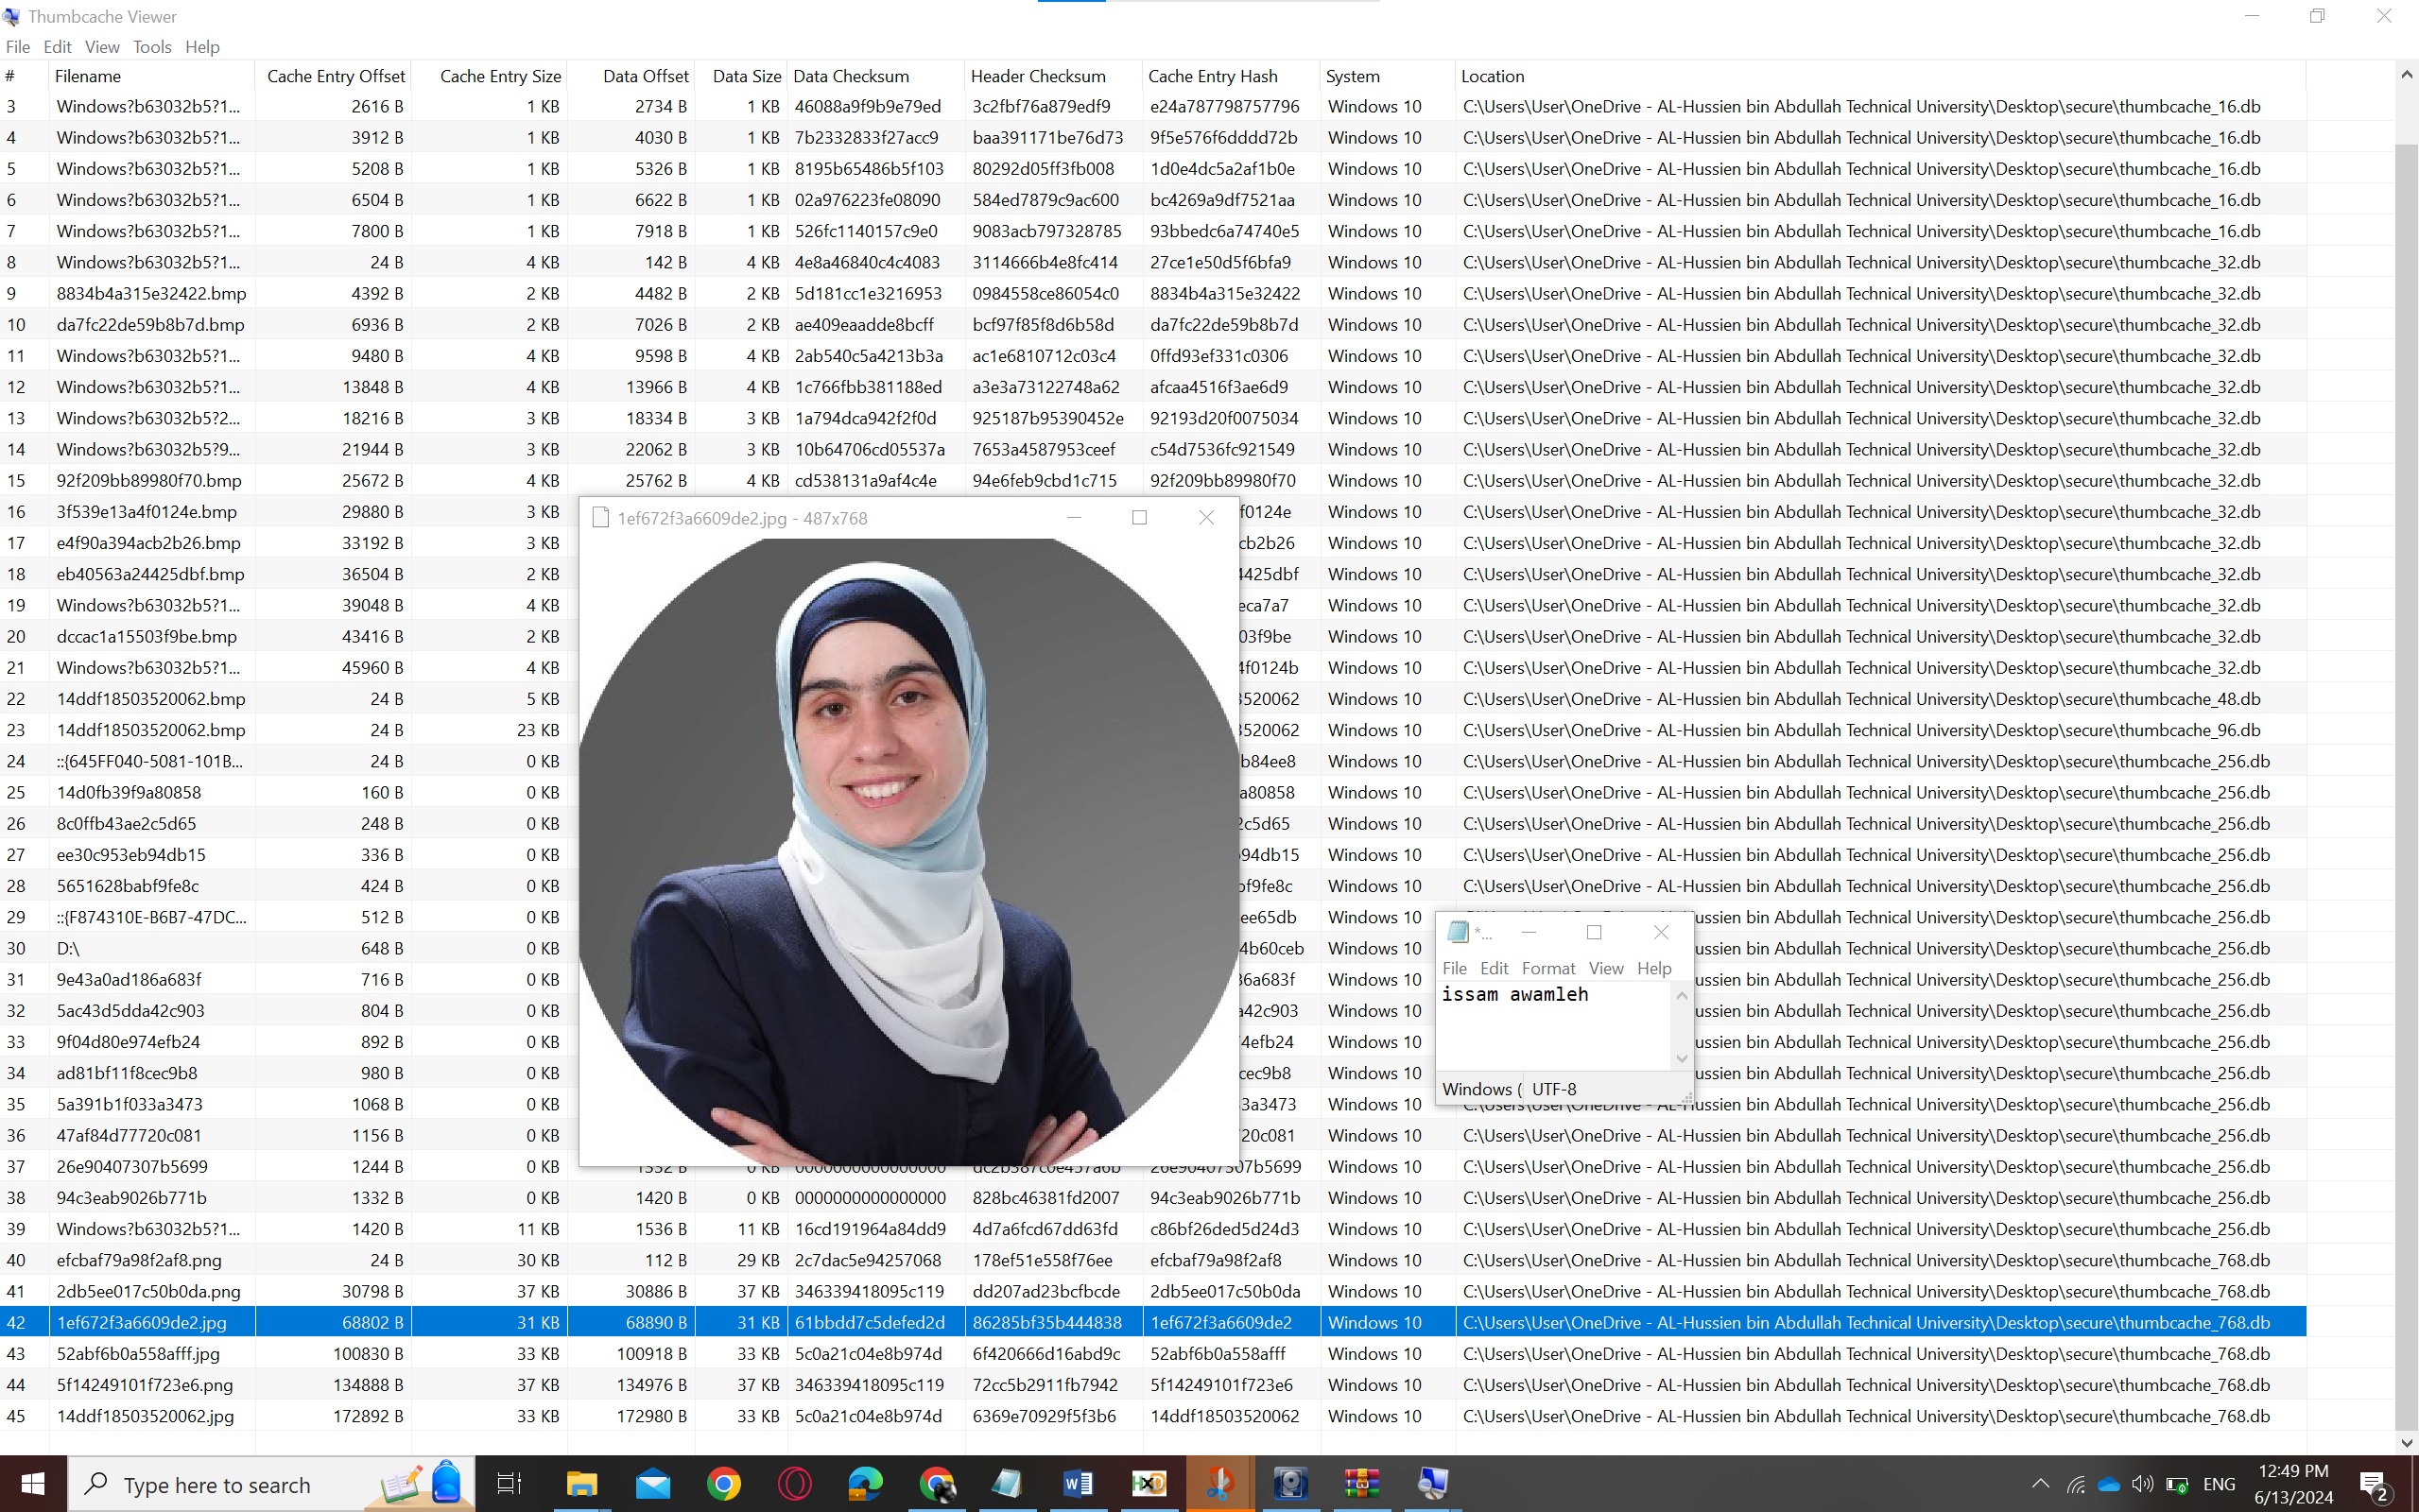

And here we go

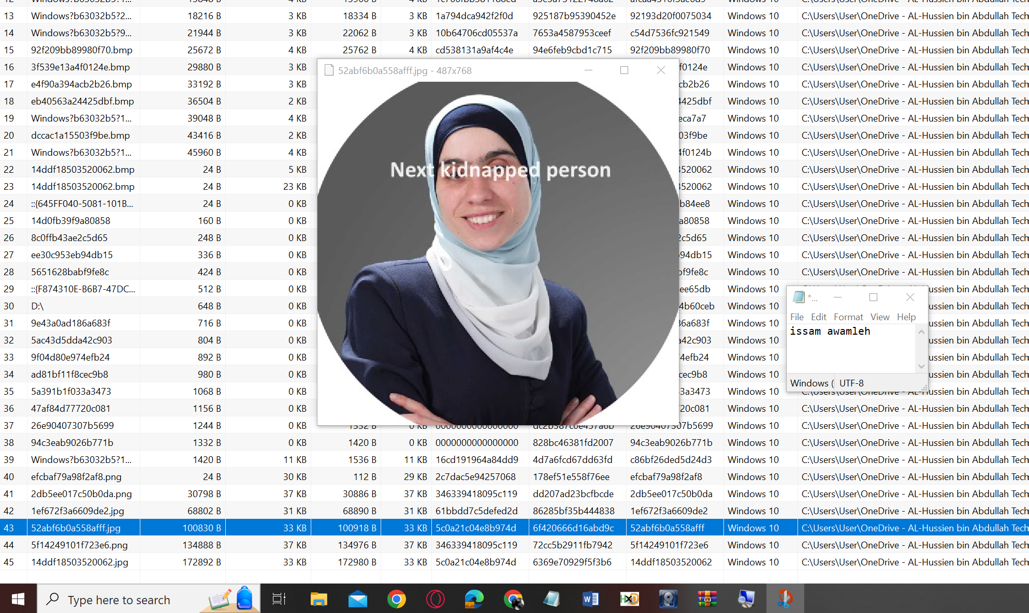

Evealtion:

Everything was easy but the last step to know It could be the thumbnail but this was straight forward by thumbnail and the project was extracted by data hiding and extracted by hxd the nature of the evidence is diffrance here it's visual thing which is pic but the project was text which make sense the eevadiance is docx file that's was key diffrance between them including the difference of the tools that used.

Finding the pic was hard I used check list of windos artifacts to find it it's take time otherwise anything else was easy.